Mar 25, 2026

Talking Points
- Claude Code
  - Terminal
  - GUI
- GitHub - Access to Claude Code
- GUI vs Terminal
  - Claude Code
  - Install Github
    - 10 mins to get it done
  - Connect Claude Code via SSH
  - Clone the Oren Repo
- Replace terminal with warp.dev

Friction Points

- GH CLI not installed
  - Claude can also brew install
  - Can’t run gh auth login in Claude Code
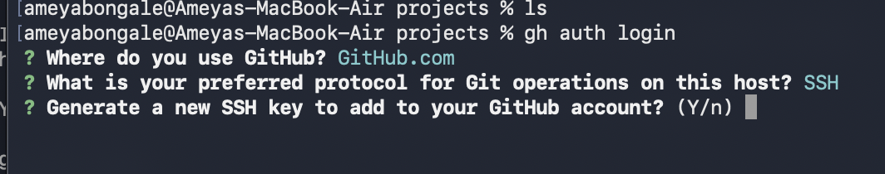

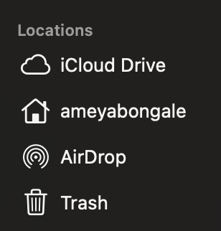

Warp.Dev

- Classic Terminal : Facelift for the terminal

